西赛尔

XSE-903-D ophthalmic operating table

Instruction for use

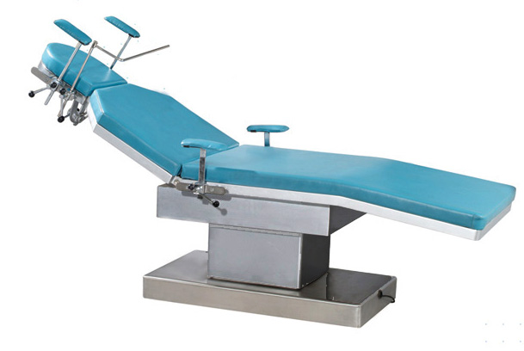

Harbin west self medical equipment co., LTD

No.26 Spring Street, Nangang District, Harbin Postal Code: 150030 Tel / Fax: (0451) 85923767

XSE-903-D ophthalmic operating table

One, Overview:
XSE-903-D operating bed is an electric operating bed specially used for the surgery of five sense organs. This product is a new type of operating bed which adopts the mechanical motor drive to lift and the backboard to tilt in large angle, and the head is manually swinging at a large angle.
Stable movement, reliable performance, low noise, low voltage, durable, beautiful appearance, can create a quiet, comfortable, casual working conditions for you. It is an advanced surgery bed with five senses in China at present.

Two，Main technical parameters
1，function：Low position, suitable for brain surgery, ophthalmology, otolaryngology and other surgery
2，control：Electric control table lifting, back and down folding; manual control head plate lifting
3，Pedal control：have
4，mesa：The bed is divided into, head plate, back plate, seat plate, the board can be placed under the box, X-ray transmission
5，Mattress：The memory sponge mattress can be disassembled
6，Base：Can be fixed and mobile
7，To configure：With a variety of accessories, suitable for ophthalmic surgery needs
8，Bed length：≥2150mm±150mm
9，Bed width：≥600mm±25mm
10，Height of ground departure：
525mm±25mm~775mm±25mm（Does not include mattresses）
11，Rise and fall distance of bed surface：≥250mm
12，Head plate, rising distance：≥120mm±10mm
13，Backplane maximum angle：Fold up the angle≥75°
14，Longitudinal moving distance of bed：250mm±10mm
15，Rated load quality is：≥135kg

Three, standard configuration
1, a pair of patient-specific scaffolding
2, a pair of curtain frame
3, doctors hand rack, a pair

Four， Main technical performance
1) This product uses DC motor drive, mechanical transmission, low voltage safety voltage control, stable operation, reliable performance.
2) table height can be adjusted between 535 ~ 785 mm, just press the manual control button, up or down, you can achieve the desired height.
3) backplane tilt angle can be adjusted between 0 ~ 75 °, but also just press the manual control button, you can achieve the desired angle.
4) The head plate reverse manual rotation, free to park to the desired angle,
Then move the locking wrench, lock it.
5) stable adjustment of operating bed: there are two plum bolts on the side of the operating bed chassis. The height of the operating bed can be smoothly adjusted by adjusting the height of the bolt.
6) the head board is equipped with the support frame for doctors to adjust the height and position at any time, and it can be unloaded when not used.
7) head plate valanced frame, adjustable height, position, when not in use can also be unloaded.
8) handrails on both sides of the bed body are equipped with armrests, which can adjust the height and position at random, and be used by the patients during the operation.

Five, electrical and safety
1) There is an electric control box in the column cover, users only need to connect the power plug to a well-grounded three-hole socket for normal use.
2) Please users to use the correct power, electrical plug and a good grounding three-hole socket, to ensure safety.
3) Hand-held controller marked with lifting and slanting signs, in case of failure or no action, check whether the plug firmly connected. Non-professionals are not allowed to open the electrical control box and handheld controller.

Six, matters needing attention
1) the operating bed should not lift the swinging head directly, so as not to damage the parts.
2) the operating bed should be disinfected according to the routine disinfection methods of medical instruments before use, and then the bed and bed can be disinfected before use.
3) In case of no lifting or tilt of the backplane does not act, first check the power, power plug, insurance, etc. are energized, troubleshooting can be used normally.
4) in case of mechanical failure, it is necessary to carefully check the relevant parts, excluding the rear can be used normally.

Seven, contact information
Tel: 0451-85923767
Fax: 0451-85923767
Address: Nangang District, Harbin Spring Street on the 26th
Zip code: 150030

Harbin west self medical equipment co., LTD

